# Solo Concept Document: House Spyder

## High Concept:

Hated and feared, the dreaded house spider is just trying to get through their day. Roam a house living the life of a house spider whilst generally causing havoc.

## Summary:

You take on the life of a house spider as you explore the unseen highways and dusty passages of an average home. Find food and try to stay out of sight! But beware… You are not the only resident! Danger lurks around every corner.

Standing in between you and home is wealth of obstacles. Squeeze under furniture, climb walls, hang from the ceiling, use any of the skills at your disposal to progress without catching the attention of the larger residents. If you are lucky the residents will be the kindly type and will scoop you up with a cup and paper, putting you outside. Push them too far however and you’ll instead be faced with the dreaded vacuum. Most deadly of all however is the terrifying house cat! Do whatever you can to avoid disturbing this sleeping, furry ball of death.

## Genre/comparisons:

Think of it as a cross between Untitled Goose Game and Pacman. Plays in a similar way to Untitled Goose Game but with more of a focused goal and a constant sense of threat.

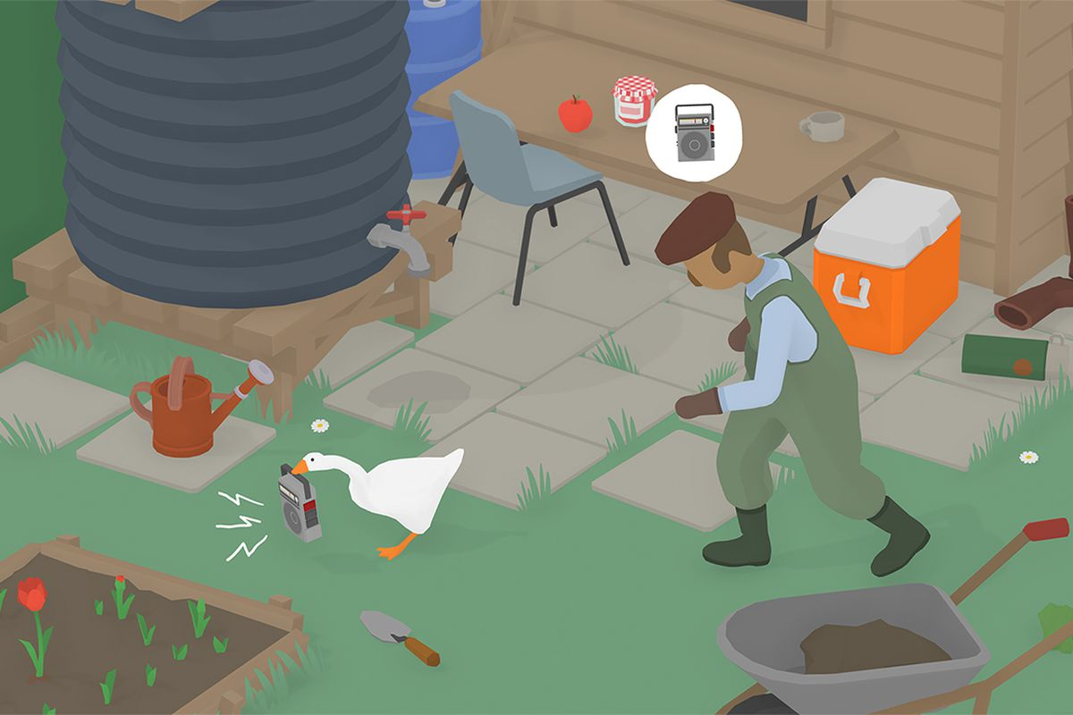

## Unique Selling Points (USPs)/features:

Part sandbox, part puzzle box, and part stealth. The game combines spatial reasoning, puzzle solving and occasional bursts of action. It takes a mundane setting and views it from a new angle.

## Description of Game:

The player is given a set starting point and then has to navigate their spider back to their webby home. Getting from A to B is no simple task. Navigating the house is an intricate maze which will also involve puzzle solving and occasional feats of daring. Foes include other spiders, the dreaded house cat and the house’s human residents. Lingering in open spaces too long will attract unwanted human attention. Are the humans the cup and paper type? Or the vacuum cleaner type? You don’t want to find out!

The house environment is a 3D cube, which can be rotated depending on what surface the spider is currently walking on. The actual gameplay is 2D. The player has a simple attack for dispensing with small bugs and rival spiders but for larger enemies you have to use a combination of puzzle solving and stealth to proceed.